Project:

Proposed specification prepared for

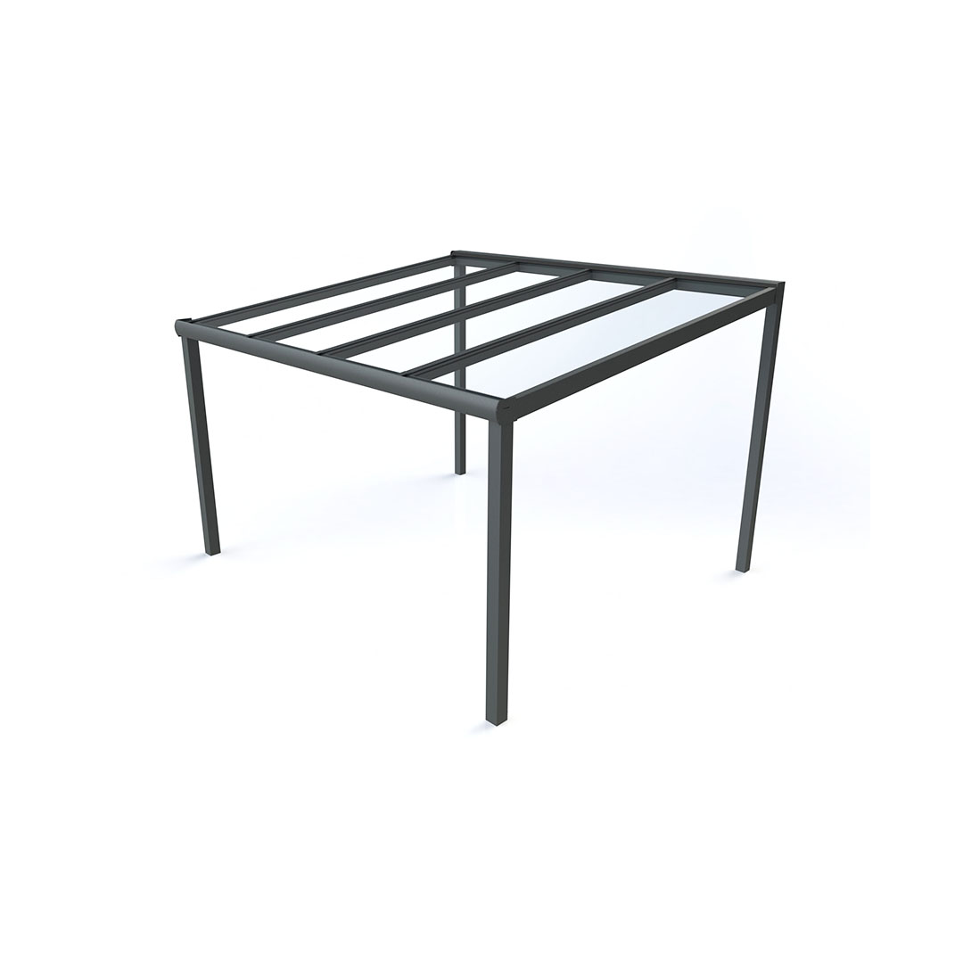

Free-Standing Mono-Pitch Canopy

- Description: WeatherSpan Free-standing Mono-Pitch Aluminium Frame Canopy with Polycarbonate/Glass roof

- Standard: To BS EN 1090

- Manufacturer: Waverley Contract & Supply Ltd
Rowan House, Guildford Road Trading Estate,
Farnham, GU9 9PZ
Tel. 01252 737973
www.waverley.co.uk
Contact: Michael Denyer
Email. michael@waverley.co.uk

- Type: Free-Standing Mono-Pitch

- Dimensions: refer to schedule and drawings for size and locations

- Frame:

  - Aluminium extrusion, 6063 T6 grade
  - 125mm rear legs with 125mm rear cross beam
  - 110mm round/square legs with integral rainwater downpipe
  - 130mm x 90mm heavy duty front profile with integral gutter with radiused/straight fascia.

  - 60mm x 120mm roof beams

  - Powdercoat finish to RAL….

- Roof sheets: 16mm multiwall polycarbonate, weight 2.7kg/m2

7.1. Finish/ Colour: Clear 85% Light Transmission
Or Opal 42% Light Transmission

Roof Sheets: 8.76mm laminate glass in clear finish, 20.8Kg/m2

- Fixing: Galvanised steel base plate bolted to suitable concrete foundation

- Rainwater management: FFL/connection underground

- Accessories/ Other requirements:
Post pads
Side infill panels – polycarbonate or aluminium panels
LED Lights
Retractable Zip Screen roller blinds – motorised or manual

- Manufacturers 10 Year Warranty on canopy system against manufacturing defects

