Project:

Proposed specification prepared for

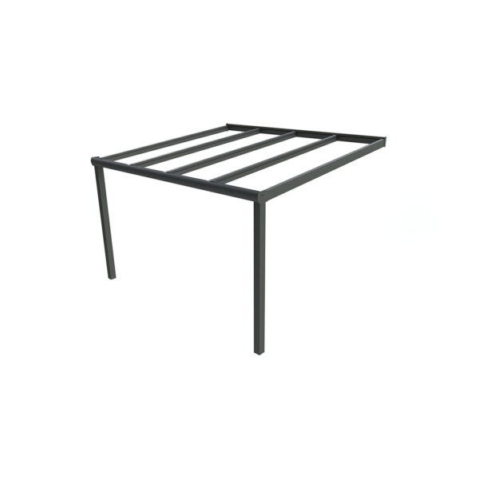

**Lean-to Canopy**

1. Description: WeatherSpan Lean-to Aluminium Frame Canopy with Polycarbonate/Glass roof
2. Standard: To BS EN 1090
3. Manufacturer: Waverley Contract & Supply Ltd

Rowan House, Guildford Road Trading Estate,

Farnham, GU9 9PZ

Tel. 01252 737973

www.waverley.co.uk

Contact: Michael Denyer

Email. michael@waverley.co.uk

1. Type: Lean-to canopy
2. Dimensions: refer to schedule and drawings for size and locations
3. Frame:
   1. Aluminium extrusion, 6063 T6 grade
   2. 110mm round/square legs with integral rainwater downpipe
   3. 130mm x 90mm heavy duty front profile with integral gutter with radiused/straight fascia.
   4. 60mm x 120mm roof beams
   5. Powdercoat finish to RAL….
4. Roof sheets: 16mm multiwall polycarbonate, weight 2.7kg/m2

7.1. Finish/ Colour: Clear 85% Light Transmission

Or Opal 42% Light Transmission

Roof Sheets: 8.76mm laminate glass in clear finish, 20.8Kg/m2

1. Fixing: Galvanised steel base plate bolted to suitable concrete foundation
2. Rainwater management: FFL/connection underground
3. Accessories/ Other requirements:

Post pads

Side infill panels – polycarbonate or aluminium panels

LED Lights

Retractable Zip Screen roller blinds – motorised or manual

1. Manufacturers 10 Year Warranty on canopy system against manufacturing defects